
Phemphetse Training Academy

Where Dreamers Rise

  - BROCHURE
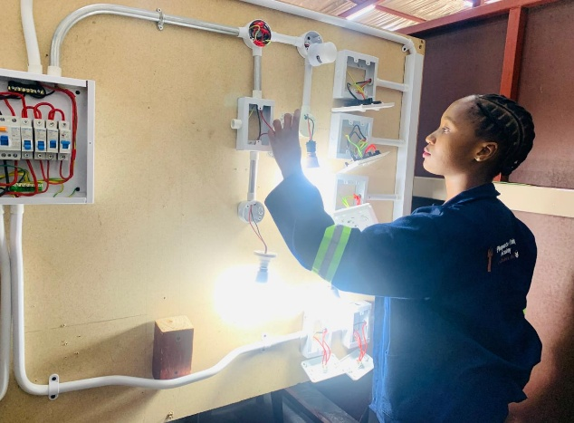
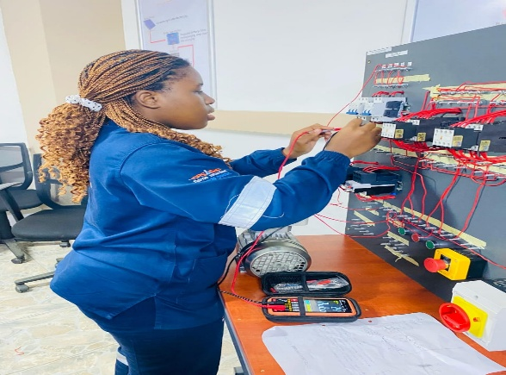

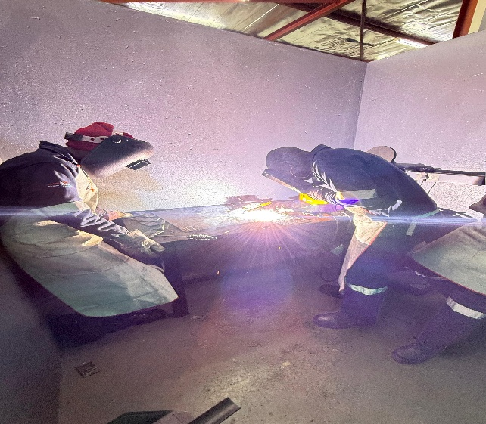
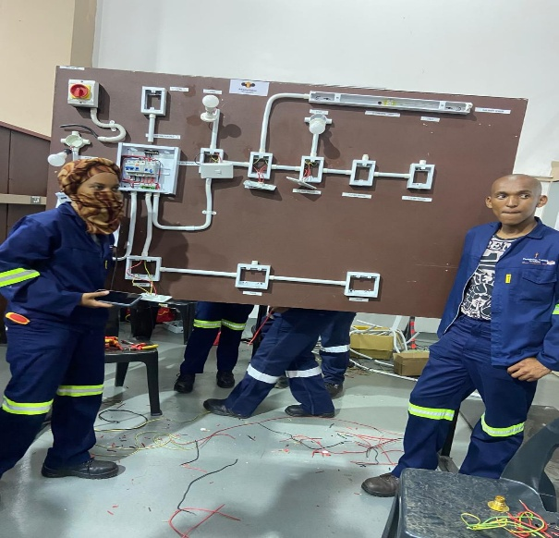

Contact Details:
✉ Email www.phemphetsegroup.co.za
☏: Phone Tel : 013 692 0387 Cell: 066 349 4149
: Web site training@phemphetsegroup.co.za

Table of contents
- About Phemphetse Trading and Projects
1.1 As Work Place Centre Provider……………………………………………….……
  - As the Skills Development Provider……….......................................................

    - Vision statement………………………………………………….……………....

    - Mission statement ……………………………………………………………….

    - Values………………………………………………………………………..........

- Full Accreditations

- Work Place Approvals…………………………………………………....................

- Training Practitioners…………………………………………………......................

- What Phemphetse Training and Projects Offers..................................................

- Specialised Skills Training……….….…………………………………...................

- Resources…………………….……………………………………………................

- Occupational Training Approach

- Artisan Recognition of Prior Learning (ARPL) Approach…………………………….
.
  - Trade Testing

- The ARPL Welding and Electrical Training Process…………................................

- Course Fees……………………………………………………………......................

- ABOUT PHEMPHETSE TRADING AND PROJECTS

  - Phemphetse Trading and Projects as the Work Place Skills Delivery

Phemphetse Trading and Projects is an Engineering Company which is registered as close corporation with 16 (sixteen) years’ experience in the fields of:
- Electrical
- Wielding
- Mechanical
- Solar Energy Systems
- PLC and Instrumentation
- Construction
To keep up with the organizational goals and objectives, strong management team, effective communication system and continued training and development programs of the personnel are implemented.
Since its inception, the Company has proved that it is capable of providing efficient electrical, welding, instrumentation and mechanical services and has an exceptional record with the existing clients namely:
- Municipalities,
- Surrounding Coal mines (Exxaro group, Anglo American, Seriti Group and Glencoe group)
- Local power stations (Kriel, Matla, Hendrina, Kusile and Kendal.

  - Phemphetse Trading and Projects as the Skills Development Provider

Phemphetse Training Academy prides itself in being an esteemed training provider that holds accreditation from various SETAs and QCTO. As an accredited institution, we are committed to delivering top-notch education and skill development.

At the core of our training academy is the firm belief that education is not just about acquiring knowledge but also about personal transformation.
“Where Dreamers Rise” we strive to embody these values and fulfil our vision and mission, providing a platform for individuals to unleash their potential, pursue their dreams and rise to new heights of success and fulfilment.

- Vision
Our Vision is to be a leading training academy where dreamers rise, empowering individuals to reach their full potential and achieve their aspiration through exceptional education and personal growth opportunities.

- Mission
Our mission is to empower our trainees to become industry-ready professionals capable of contributing to the advancement of the engineering sector and the country at large.
Values

- Excellence:
We strive for excellence in all aspects of our training.

- Integrity:
Uphold the highest standards of integrity, honesty and ethics in all our interactions.

- Innovation:
Embrace innovation as a driver of success.

- Collaboration:
Recognize the value of collaboration and teamwork.

- Impact:
We aspire to make a positive impact on society by enabling individuals to pursue their dreams and contribute meaningfully to their communities.

- Inspiration:
We aim to inspire individuals to dream big and believe.

- Objectives
- To impart new knowledge and information that will enable employee/a learner to do a job competently
- To impart practical engineering skills in the areas of electrical, wielding and mechanical
- Through training and development, to minimize the skills gap and shortage in the country
- To prepare a learner to enter into a job market
- To deliver our training programs within the required time
- To certify the learners using an accredited bodies like EWSETA, MERSETA and QCTO
1.3. WHAT PHEMPHETSE TRADING AND PROJECTS OFFERS

Phemphetse Trading and Projects prides itself in being an esteemed Training Provider that is accredited with:

FULL ACCREDITATIONS

2.1 Full Qualifications Accredited Training Programs that we offer:

- EWSETA Levels 2,3 and 4 in Electrical Engineering
- MERSETA Welding Engineering.
- QCTO Occupational Electrical
- QCTO Welding Engineering
- QCTO Solar Energy System Service technician
- ARPL Electrical Gap training and Trade Test preparation
- ARPL Welding Gap training and Trade Test preparation

  - ELECTRICAL TECHNINCAL SKILLS PROGRAMME

- Cable Joints and Terminations Fundamental of Electricity
- Electronics
- Transformers
- Renewable Energy Skills Programme
- Renewable Energy Skills 3 – 4 Months
- Basic PLC

Basic Electricity

- Power Generation and Distribution
- Basic concept of electricity
- The basic principles of voltage and current flow in an electrical circuit
- Magnetic Theory
- Electrical Units and Symbols
- Types of circuits (Series and Paralell circuits)

6.2 Cable Joints and Terminations

- Overview
- Constructional Aspects of Cables
- Cable connections in Joints and Terminations
- Joints and Termination Theory
- Stress control in Cable Joints and Terminations
- Practical aspects of cable Jointing and Termination work
- Cable Termination to Equipment
- Standards and Testing
- Failures and Analysis

6.3 Transformers

- Standards
- Cooling Code and Insulation Liquid
- Technical Aspects
- Product Portfolio
- Product Breakdown
- Transformer Classifications
- Accessories
- Package and Unit Substations
- Design and Structure
- Service and Testing

6.4 Solar Energy System

- Fundamentals of Electricity
- Renewable Energy Perspective
- Safety Tools and Equipment
- Solar Power System Installation Preparation
- Major Four Component Electrical Switches
- Design Of Solar Photovoltaic System
- Calculation
- Mounting Structure and Rail Mounting
- Rail Mounting
- Wire and cable, Solar Power Wiring
- Problems associated with Solar Power System
- Common mistakes during installation

6.5 Medium Voltage Course

- Workshop Rules
- Medium Voltage Substation
- Power Transformers
- Earthing Practice
- Basic Principles of electrical protection
- Electrical Protection Relays
- Isolation Protections

6.7 PLC

- Introduction to PLC
- PLC Controllers
- Input and Output Devices
- Electromagnetic Relay Concept and PLC Program
- PLC Instructions
- Practical PLC Programming using IEC Standards

- SOFT SKILLS TRAINING COURSE
- Manage Expenditure against Budget
- Manage Personal Expenditure
- Transformational Leadership
- Apply Management Practices in order to achieve short and mid-term objectives
- Perform Basic Fire Fighting
- Tender to secure for new ventures
- Manage Finances of new Venture
- Produce Business Plans
- Apply Principles costing and prices
- Basic Computer Courses

- RESOURCES
Phemphetse Trading and Projects is a highly resourced academy with Electrical, Welding and Solar Energy System and administration resources such as:
- Appliances
- Equipment
- Machinery
- Technology Computer
- Projectors
- Air Conditioners
- Surveillance camera system
- Electrical, Welding, Solar energy and general storage places
- Human resource- Practitioners and Administrators

- OCCUPATIONAL APPRENTICESHIP TRAINING APPROACH

9.1 APPRENTICESHIP TRAINING PROGRAMMES OFFERED

- Types of training programmes
- Occupational Certificate: Electrician - Level 4 - 360 credits
- Occupational Certificate: Welder- Level 4- 373 credits
- Occupational Certificate: Solar Photovoltaic service technician- Level 5- 344 credits
- Duration- Occupational Training is a three (3) Program
- Curriculum

- ARTISAN RECOGNITION OF PRIOR LEARNING (ARPL) & TRADE TESTING APPROACH

10.1 Semi-skilled unemployment candidate’s minimum requirements

- The applicant must be older than 19 years
- The applicant must have a minimum of (3) years’ workplace experience on the trade that he/ she wants to complete
- Original services letter
- Certified Identity Copy
- Certified Certificates
- Curriculum Vitae

10.2 Service letter must have the following information

- Company logo and letter head
- Company registration number, address and contact details
- The letter must have a start date and end date of employment
- The letter must state you are semi-skilled tradesman or assistant to trade
- The letter must indicate tasks according to your job description
- The letter must be signed by the immediate supervisor
- Contact details of person who signs the letter. It very important for verification process
- Company stamp compulsory
VERIFICATION | GAP TRAINING | TOOL KIT | SERIAL NUMBER | PREPARATION | TRADE TEST
Pre-Assessment  /Evolution test | Price per Day | 2 days | After Toolkit has been completed | Price per Day | 2 days

- WELDING TECHNICAL SKILLS TRAINING

  - ARC Welding

- Select use and care for engineering power tools.
- Select use and care for engineering measuring equipment
- Identify and select material to specification
- Welding Mild Steels
- Welding Positions and cutting 1F, 2F,3F,4F

11.3 Gas Cutting and Gas Welding
- Cut Materials using oxy-fuel gas cutting process
- Braze metals using oxy-fuel brazing process
- Weld workplace using oxy-acetylene gas welding process in the down-hand position

11.4 (Argon) TIG Welding

- Use welding definitions and symbols.
- Welding Mild Steels in all positions
- Welding Stainless Steels in all positions.
- Welding Aluminium in all positions
- Welding Galvanized in all positions
- Weld 50mm Diameter Carbon steel pipe from 1G,2G,3G,4G,5G,6G Positions

- RENEWABLE ENERGY

12.1 SOLAR ENERGY SYSTEM

Module 1
- Renewable energy Concept
- Solar Power Systems
- Major Solar Energy Components
- Electrical Switches
- Designing of Solar Photovoltaic (PV) Systems

Module 2
- Calculations and Sizing
- Hybrid Photovoltaic System

Module 3
- Safety Tools and Equipment
- Power Tools
- Wiring Tools and Materials

Module 4
- Solar Power Installation
- Solar Power System Installation
- Solar Power System -Mounting Structures
- Key Concepts to know when Mounting the Panels
- Rail Mounting Systems
- Solar Power System Wiring
- Wire and Cables
- How does Shade and snow impact Solar Panels
- Problems Associated with Solar Power Systems
- Common Mistakes During Installations
  - CO2 Welding
- Select use and care for engineering power tools.
- Select use and care for engineering measuring equipment
- Identify and select material to specification
- Welding Definitions and Symbols
- Welding Mild Steels plates
- Welding Stainless Steels Plates
- Welding Galvanized Plates
- Welding Positions and cutting all positions
- Registration Process
13.1 Option 1
- Registration of various courses offered according t the need, can take place on-line through our website

13.2 Option 2
- Visit our Training Academy or through direct phoning to the Academy
13.3 Quotation, Boking and Registration

- If you would like to request a quotation and registration, please visit our Phemphetse Trading and Projects @ www.phephetsegroup.co.za and follow the prompts on the apply now tab.

